## CHERRY IN LINE

**Chapter 5**

**Findings, Results, and Analysis**

5.2 Electrical Audit

**Load Flow Analysis**

**DEFINTION OF TERMS (REFERENCE : PHILIPPINE DISTRIBUTION CODE):**

**1. ACTIVE POWER :**

The time average of the instantaneous power over one period of the electrical wave, measured in watts (W) or multiples thereof. For AC circuit or Systems , it is the product of the root-mean –square (RMS) or Effective value of the voltage and the RMS value of the in-phase component of the current. In a three phase system, it is the sum of the Active Power of the individual phases.

**2. APPARENT POWER:**

The product of the root-mean –square (RMS) or Effective value of the current and root –mean –square of the voltage. For AC circuit Systems, it is the square root of the sum of the squares of the Active Power and Reactive power, measured in volt-amperes (VA) or multiples thereof.

**3. REACTIVE POWER**

The component of the electrical power representing the alternating exchange of stored energy (inductive or capacitive) between sources and loads or between two systems, measured in VAR, or multiples thereof. For AC circuits or systems, it is the product of the RMS voltage and the RMS value of the quadrature component of alternating current. In a three phase system, it is the sum of the Reactive power of the individual phases

**4 HARMONICS (THD)**

Harmonics shall be defined as sinusoidal voltage and currents having frequencies that are integral multiples of the fundamental frequency.

**A. AS PER DESIGN**

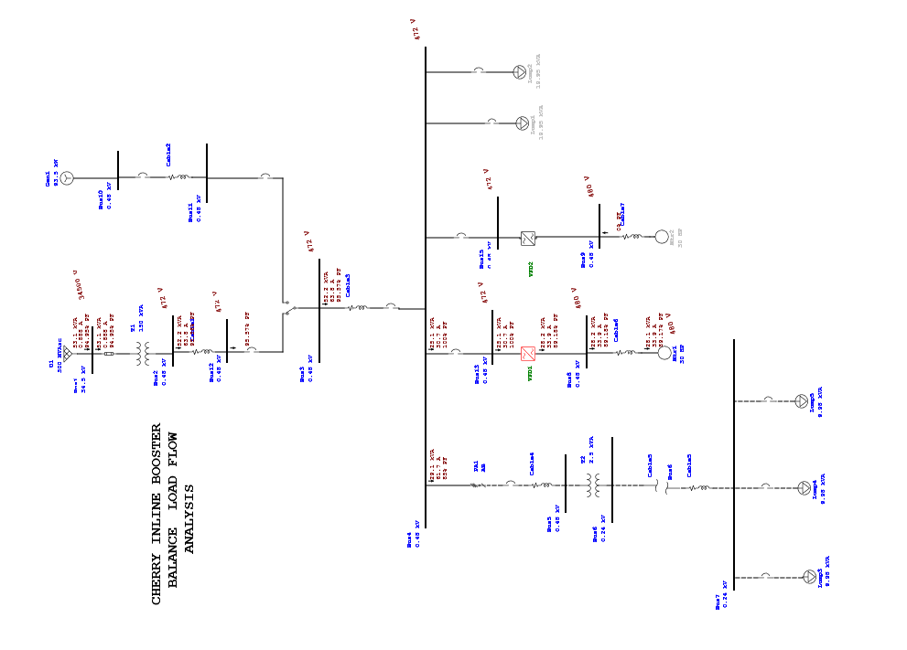

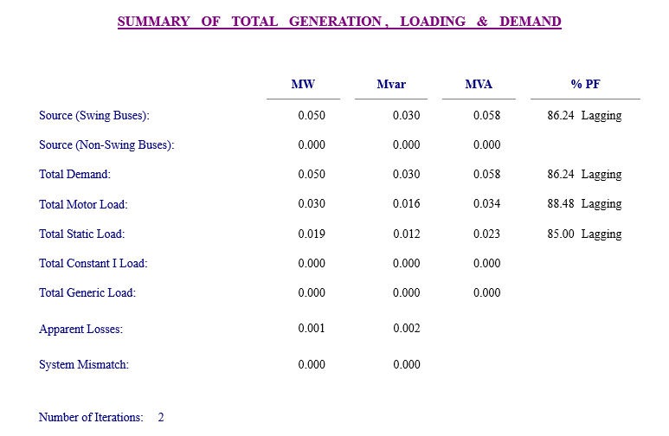

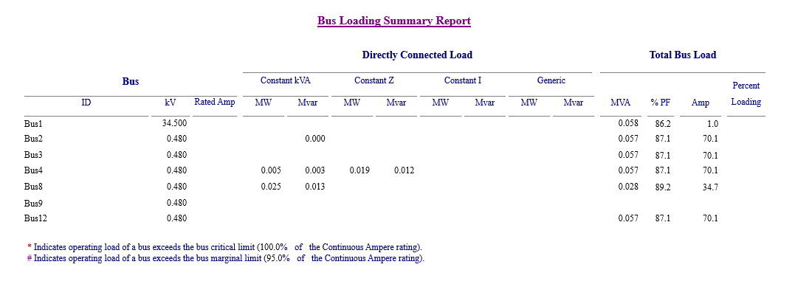

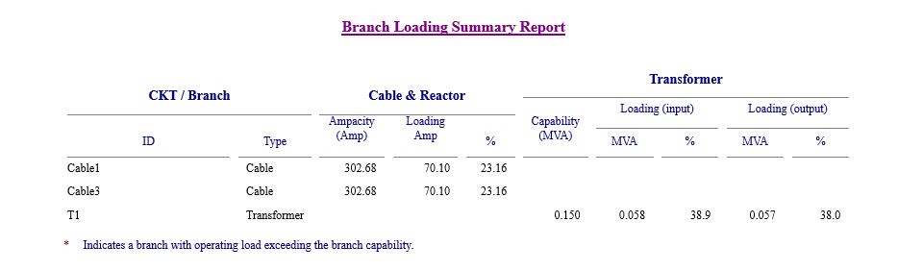

**B. AS PER ACTUAL USING POWER QUALITY ANALYZER**

**MAIN:250 AMPERES**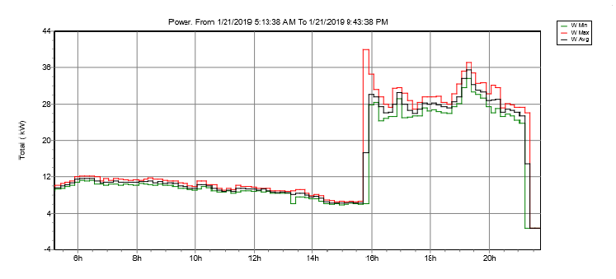

**FEEDER : VFD-1 FOR 30 HP MOTOR**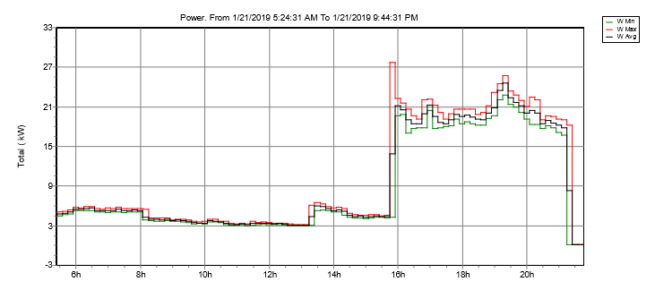

**FEEDER : VFD-2 FOR 30 HP MOTOR**